Recent Deaths: Billy Harrington

Anniversaries: Vera Monaghan, Janette Barker
Sick: Susan O’Sullivan, Chris Burns, Joan Bathgate, Terri Scott, Mark Weir, Cate Poynton, Josephine Sciberras and Laura Burns.
May our healing God touch the lives of our sick bringing them comfort & peace.
Sunday 8th August –Mass– Wk 2
Ouyen: 11:00 am
Reader: Peter Shaddock
Prayers of the Faithful: Marie Shaddock
Offertory Procession: Flora Moulder & Jona Kilaton
Projectionist: Louise Fitzpatrick Leach

Sunday 15th August – Mass – Wk 3
Ouyen: 8:30 am
Reader: Marie Shaddock
Prayers of the Faithful: Peter Shaddock
Offertory Procession: Melanie Grace & Judy Dowsley
Projectionist: Cara Brady

Collections: 18th & 25th. 7. 2021

Ouyen: $0.00

Planned Giving: $0.00

Church Cleaning:

August – Faye Nihill & Ellen Bonica

Presbytery Cleaning:

August – Marie Shaddock
Sacrament of Reconciliation:
After Mass (11:45am) on the 2nd & 4th Sundays of the month, and of a Thursday afternoon during and after Adoration and or Mass (in consultation with Father) or at any other time by appointment with Father.

Adoration of the Blessed Sacrament: Thursdays 2:00pm – 5:00 pm, usually followed by Mass; all welcome.
St Joseph’s Parish New Mass Timetable
Wk 1 Patche Mass 10:00am 1stFriday
Ouyen Assembly 9:00am Sunday
Wk 2 Ouyen Mass 11:00am Sunday
Wk 3 Ouyen Mass 8:30am Sunday
Wk 4 Ouyen Mass 11:00am Sunday
U’Bool Mass 3:00pm Sunday
Wk 5 Ouyen Mass 11:00am Sunday

We are back!! The latest Covid regulations allow us to have up to 100 people indoors and up to 300 people outdoors. In general, a density quotient of 1 person per 4 square metres applies. However, a venue smaller than 100 square metres can have up to 25 people per venue before the density quotient applies. In other words, even very small churches are permitted to have up to 25 people for a religious gathering. For a gathering of more than 25 people, the number would be calculated at 1 person per 4 square metres. Masks must be worn, except when receiving communion or reading etc. COVID Check-in Marshals must ensure attendees check-in.
If you have any concerns or questions, please phone: 0417660893 (Marie)
Special Prayers have been asked for Terri Scott, let us keep her and all the family in our prayers.
An answer to our prayers: On the 18th of July Bishop Paul was to install Bill Lowry and Matt Restall, both 6th year seminarians for the Diocese of Ballarat, as candidates for ordination. Bishop Paul was also to install Cay Trinh in the ministry of Acolyte. Cay, is from Vietnam, and is a fourth year seminarian for our Diocese. Unfortunately, this didn’t happen but it will as soon as we are able to return to Mass. In the meantime, let us thank God that our prayers for more seminarians are being heard and answered. Please continue to pray for them and for more to come!
Australian Catholic Men's Gathering 2021
As an initiative of the Australian Catholic Bishops, the National Catholic Men’s Gathering aims to inspire and encourage all men with a vision for personal discipleship, service and mission in the family, parish/diocese and the world. The online program hopes to reinforce that it is important to gather as men in the faith environment of the Church and be challenged to ensure the Gospel is alive in our homes, parishes/dioceses and our communities. The National Catholic Men’s Gathering is again being offered as a free event for registered participants and is available from Saturday, July 31st, to register go to :https://www.nce.catholic.org.au/catholicmen

The Eighteenth Sunday in Ordinary Time
Reflections from Scott Hahn . . .
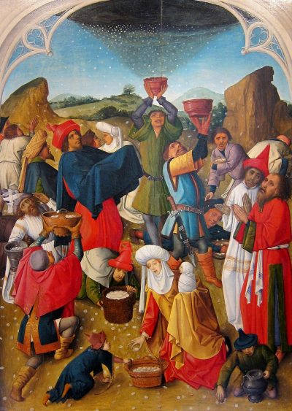
The journey of discipleship is a lifelong exodus from the slavery of sin and death to the holiness of truth on Mount Zion, the promised land of eternal life.
The road can get rough. And when it does, we can be tempted to complain like the Israelites in this week’s First Reading.
We have to see these times of hardship as a test of what is in our hearts, a call to trust God more and to purify the motives for our faith. As St Paul reminds us, we must leave behind our old self-deceptions and desires and live according to the likeness of God in which we are made.
Jesus tells the crowd in this week’s Gospel, that they are following Him for the wrong reasons. They seek Him because He filled their bellies. The Israelites, too, were content to follow God so long as there was plenty of food.
Food is the most obvious of signs—because it is the most basic of our human needs. We need our daily bread to live. But we cannot live by this bread alone. We need the bread of eternal life that preserves those who believe in Him.
The manna in the wilderness, like the bread Jesus multiplied for the crowd, was a sign of God’s Providence—that we should trust that He will provide, it was also a sign pointing to the spiritual nourishment God wanted to give.
These signs pointed to their fulfillment in the Eucharist, the abundant bread of angels we sing about in this week’s Psalm.
This is the food that God longs to give us. This is the bread we should be seeking. But too often we don’t ask for this bread. Instead, we seek the perishable things of our everyday wants and anxieties. In our weakness we think these things are what we really need. We have to trust God more. If we seek first His kingdom and His righteousness, all these things will be ours as well.

This Week’s Plenary Council Reflection: From the Gospel: “I am the bread of life.
He who comes to me will never be hungry; he who believes in me will never thirst.” Recognising that fewer people today participate in the sacramental life of the Church than in previous times, the question of
how best to provide formation on the sacraments arises. Such formation will need to focus on both deepening people’s faith as well as increasing their knowledge. Part of this also includes the mission of the Church and the need to see the connection between sharing the Bread of Life and providing bread for life for those less fortunate. Our approach must be holistic if it is to be sustainable and in line with the Gospel.

Inspiration from the Saints: “To write well and speak well is mere vanity if one does not live well.” St Bridget of Sweden

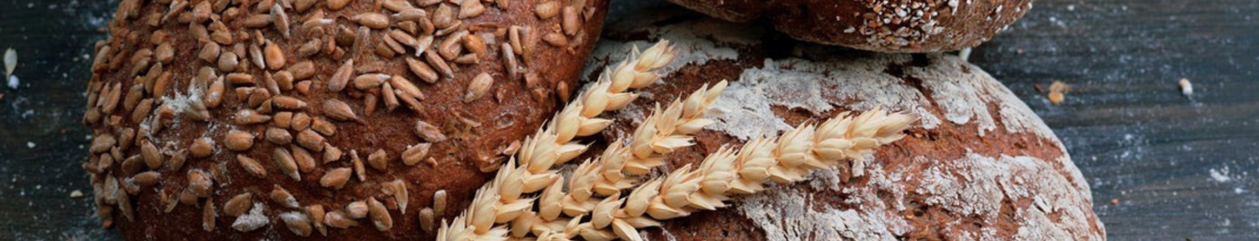
EIGHTEENTH SUNDAY IN ORDINARY TIME YEAR B
First Reading
A reading from the book of Exodus
The whole community of the sons of Israel began to complain against Moses and Aaron in the wilderness and said to them, ‘Why did we not die at the Lord’s hand in the land of Egypt, when we were able to sit down to pans of meat and could eat bread to our hearts content! As it is, you have brought us to this wilderness to starve this whole company to death!’
Then the Lord said to Moses, ‘Now I will rain down bread for you from the heavens. Each day the people are to go out and gather the day’s portion; I propose to test them this way to see whether they will follow my law or not.’
‘I have heard the complaints of the sons of Israel. Say this to them, “Between the two evenings you shall eat meat, and in the morning you shall have bread to your hearts content. Then you will learn that I, the Lord, am your God.”’ And so it came about: quails flew up in the evening, and they covered the camp; in the morning there was a coating of dew all round the camp. When the coating of dew lifted, there on the surface of the desert was a thing delicate, powdery, as fine as hoarfrost on the ground. When they saw this, the sons of Israel said to one another, ‘What is that?’ not knowing what it was. ‘That’ said Moses to them ‘is the bread the Lord gives you to eat.’
Responsorial Psalm
(R.) The Lord gave them bread from heaven.
1. The things we have heard and understood,
the things our fathers have told us,
we will tell to the next generation:
the glories of the Lord and his might. (R.)
2. He commanded the clouds above
and opened the gates of heaven.
He rained down manna for their food,
and gave them bread from heaven. (R.)
3. Mere men ate the bread of angels.
He sent them abundance of food.
He brought them to his holy land,
to the mountain which his right hand had won. (R.)
Second Reading
A reading from the letter of St Paul to the Ephesians
I want to urge you in the name of the Lord, not to go on living the aimless kind of life that pagans live. Now that is hardly the way you have learnt from Christ, unless you failed to hear him properly when you were taught what the truth is in Jesus. You must give up your old way of life; you must put aside your old self, which gets corrupted by following illusory desires. Your mind must be renewed by a spiritual revolution so that you can put on the new self that has been created in God’s way, in the goodness and holiness of the truth.
Gospel Acclamation
Alleluia, alleluia!
No one lives on bread alone, but on every word that comes from the mouth of God.
Alleluia!
Gospel
A reading from the holy Gospel according to John
When the people saw that neither Jesus nor his disciples were there, they got into boats and crossed to Capernaum to look for Jesus. When they found him on the other side, they said to him, ‘Rabbi, when did you come here?’
Jesus answered: ‘I tell you most solemnly, you are not looking for me because you have seen the signs but because you had all the bread you wanted to eat. Do not work for food that cannot last, but work for food that endures to eternal life, the kind of food the Son of Man is offering you, for on him the Father, God himself, has set his seal.’
Then they said to him, ‘What must we do if we are to do the works that God wants?’ Jesus gave them this answer, ‘This is working for God: you must believe in the one he has sent.’ So they said, ‘What sign will you give to show us that we should believe in you? What work will you do? Our fathers had manna to eat in the desert; as scripture says: He gave them bread from heaven to eat.’ Jesus answered: ‘I tell you most solemnly, it was not Moses who gave you bread from heaven, it is my Father who gives you the bread from heaven, the true bread; for the bread of God is that which comes down from heaven and gives life to the world.’
‘Sir,’ they said ‘give us that bread always.’ Jesus
answered: ‘I am the bread of life. He who comes to
me will never be hungry; he who believes in me
will never thirst.’
Communion Antiphon
Wis 16:20
You have given us, O Lord, bread from heaven,
endowed with all delights and sweetness in every taste.

The following is from Jane Munro via the CWL to league members and all Victorians

Your voice is urgently needed

Once again, Fiona Patten is attempting to remove the Lord's Prayer from the Victorian Parliament - and you can help stop her.
Ms Patten will move a motion in the Legislative Council on 4 August to remove the prayer, and proposes to replace it with “a moment of silent religious observance or reflection” each sitting day.
Make no mistake, this isn’t about religious freedom and inclusivity. It’s the removal of God from one of the most important institutions in our society.
The Lord’s Prayer has a legitimate place in Parliament and has been part of parliamentary process since 1918. It is symbolic of the Christian ethos underpinning Western civilisation that has fostered free and prosperous societies, including our liberal democracy.
Even the atheist political philosopher, Jurgen Habermas, said: “Egalitarian universalism - from which sprang the ideas of freedom, human rights and democracy - is the direct heir to the Judaic ethic of justice and the Christian ethic of love. To this day, there is no alternative to it.”
The Lord’s Prayer is not divisive; it is unifying. It invites reflection and humility before taking major decisions that affect all Victorians.
Please email or ring your Upper and Lower House MPs now to urge them to keep the Lord's Prayer in Victorian Parliament.
Our Members are Wendy Lovell & Jaclyn Symes. If you go onto the ACL (Australian Christian Lobby) website they have the wording already provided for you -you only have to fill in your name and address. They also direct it to the correct members.
This is just the beginning and is extremely urgent so please don't delay.

