Recent Deaths: Alfred Sultana

Anniversaries:
Sick: Susan O’Sullivan, Chris Burns, Joan Bathgate, Terri Scott, Mark Weir, Cate Poynton, Josephine Sciberras and Judy Dowsley
May our healing God touch the lives of our sick bringing them comfort & peace.
Sunday 22nd August – Mass – Wk 4
Ouyen: 11:00 am
U’bool: 3:00pm
Reader: John Galvin
Prayers of the Faithful: Carmel Vallance
Offertory Procession: Faye Nihill & Cheryl Anderson
Projectionist: Marie Shaddock

Sunday 29th August – Mass – Wk 5
Ouyen: 11:00 am
Reader: Gerald Leach
Prayers of the Faithful: Louise Fitzpatrick Leach
Offertory Procession: Brady Family
Projectionist: Marie Shaddock

Collections: 8th. 8. 2021

Ouyen: $0

Planned Giving: $0

Church Cleaning:

August – Faye Nihill & Ellen Bonica

Presbytery Cleaning:

August – Marie Shaddock
Sacrament of Reconciliation:
After Mass (11:45am) on the 2nd & 4th Sundays of the month, and of a Thursday afternoon during and after Adoration and or Mass (in consultation with Father) or at any other time by appointment with Father.

Adoration of the Blessed Sacrament: Thursdays 2:00pm – 5:00 pm, usually followed by Mass; all welcome.
St Joseph’s Parish Mass Timetable
Wk 1 Patche Mass 10:00am 1stFriday
Ouyen Assembly 9:00am Sunday
Wk 2 Ouyen Mass 11:00am Sunday
Wk 3 Ouyen Mass 8:30am Sunday
Wk 4 Ouyen Mass 11:00am Sunday
U’Bool Mass 3:00pm Sunday
Wk 5 Ouyen Mass 11:00am Sunday
We are back again!! And hopefully for an extended time but let us remember those in Melbourne and elsewhere who are not so lucky. The big lesson Covid has taught us is that nothing in this world is permanent. On this feast day of the Assumption let us remember where our real and only permanent home is and focus more on heaven and getting there. Let’s ask our Lady to guide us and guard us in these special times. *If you have any concerns or questions, please phone: 0417660893 (Marie)
Social Justice Sunday – August 29, 2021
The Bishops’ Social Justice Statement 2021-22: Cry of the Earth, Cry of the Poor, affirms that “we human beings need a change of heart, mind, and behaviour”. It draws from Scripture, from the theological tradition, from Catholic Social Teaching and from the wisdom of the world, including the insights of the First Nations. You can download the statement from the ACBC Office for Social Justice at the website below or the hard copy will be out soon.
https://socialjustice.catholic.org.au/2021/06/24/social-justice-statement-2021-22/.
Fr Michael McKinnon will be in Mildura from Saturday 14th August until Monday 23rd August, and we have booked the Irymple Hotel on Wednesday 18th August at 6pm for a sit-down meal. Please note that you will need to pay for your own meal and drinks. If you would like to catch up and farewell Fr Michael before he leaves for Peru, please contact the Sacred Heart Parish Office (0417 862 082) for a booking asap. At this stage we have made the booking for 40 people and your early response will indicate whether this number changes.
Natural Fertility Awareness Week 23-29Aug.
See over the page for more details.

The Assumption of the Blessed Virgin Mary
On this feast, we praise God who has taken the sinless Virgin Mary, body and soul, into His glory.
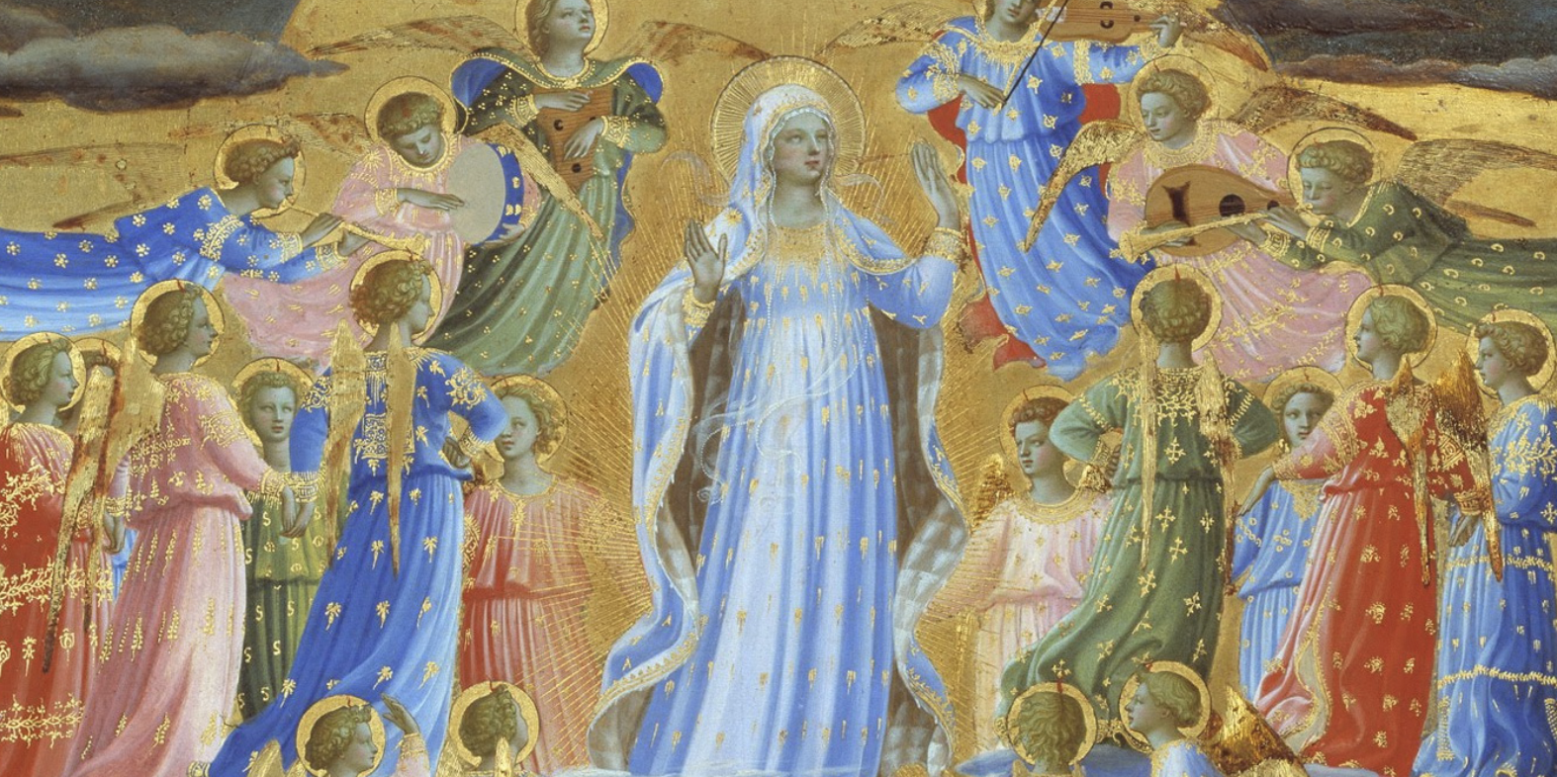
In our first reading, from Revelation, we find God’s temple in heaven opened and the Ark of the Covenant revealed. The most sacred item in Israel’s history, the Ark had been missing since the Temple’s destruction in 586 B.C. Thus, John reports some startling news. Even more startling is his revelation that the sacred vessel is now a woman, who is mother of the royal Son of David, the Messiah.
Of this woman, then, we sing to God as the ancient Israelites sang: “The queen stands at your right hand, arrayed in gold.” In the court of King Solomon, we glimpse Israel’s traditional arrangement: Solomon’s mother, Bathsheba, takes her place at the king’s right hand
At Mary’s Assumption, as we see in Revelation, the queen once again takes her place at the right hand of the Son of David.
Our second reading shows us why this is fitting: “in Christ shall all be brought to life, but each one in proper order.” What is implicit in St. Paul’s statement is revealed in Revelation. The consummation of Christ’s work has begun, as is proper, with the Assumption of the queen mother.
John’s Apocalypse shows also the fulfillment of our Gospel. There, Mary, pregnant with Jesus, retraces the steps of David as he brought the Ark to Jerusalem (see 2 Samuel 6). Mary “arose and went” into the hill country, just as David “arose and went” to that region. Upon Mary’s arrival, Elizabeth is awestruck, just as David was before the Ark. The encounter causes the baby John to leap with excitement, as David leapt before the Ark. And Mary stayed in the “house of Zechariah” for “three months,” as the Ark remained in the “house of Obed-edom” for the same period.
Mary is the vessel of God’s presence, and she is queen mother. She reigns now in splendour with Jesus in the heavenly Jerusalem.

This Week’s Plenary Council Reflection: From the Gospel: “His mercy reaches from age to age.” In 2015/16, Pope Francis proclaimed a Year of Mercy in which he placed mercy at the centre of the Church’s heart and mission. He said mercy “constitutes her very existence, through which the profound truths of the Gospel are made manifest and tangible. Everything is revealed in mercy; everything is
resolved in the merciful love of the Father.” How do we do that: as a Church, as a Parish, as individuals?

NATURAL FERTILITY AWARENESS WEEK: August 23-29 Tracking Fertility -Tracking Health Would you like to discover a way of tracking your cycles and understand a method of family planning in which both members of the couple share this awesome responsibility?
This knowledge is something every woman should have and every man can learn! The Billings Ovulation Method® is based on sound science and has been proven an effective Method to achieve or postpone a pregnancy and to monitor reproductive health. More info can be found at: https:/billings.life/en/
OR Contact Billings LIFE via email: enquiries@thebillingsovulationmethod.org for a teacher nearest to you.

Wisdom From the Saints: “Our body is not made of iron. Our will is not made of steel. Live and hope in the Lord and let your service be according to reason.” St Clare – founder of the Poor Clares, under the influence of St Francis

The Assumption of the Blessed Virgin Mary 15th August

First Reading
A reading from the first book of the Apocalypse
The sanctuary of God in heaven opened, and the ark of the covenant could be seen inside it.
Now a great sign appeared in heaven: a woman, adorned with the sun, standing on the moon, and with the twelve stars on her head for a crown. She was pregnant, and in labour, crying aloud in the pangs of childbirth. Then a second sign appeared in the sky, a huge red dragon which had seven heads and ten horns, and each of the seven heads crowned with a coronet. Its tail dragged a third of the stars from the sky and dropped them to the earth, and the dragon stopped in front of the woman as she was having the child, so that he could eat it as soon as it was born from its mother. The woman brought a male child into the world, the son who was to rule all the nations with an iron sceptre, and the child was taken straight up to God and to his throne, while the woman escaped into the desert, where God had made a place of safety ready. Then I heard a voice shout from heaven, ‘Victory and power and empire for ever have been won by our God, and all authority for his Christ.’

Responsorial Psalm Ps 44:10-12. 16. R. v.10

(R.) The queen stands at your right hand, arrayed in gold.

1. The daughters of kings are among your loved ones. On your right stands the queen in gold of Ophir. Listen, O daughter, give ear to my words: forget your own people and your father’s house. (R.)

2. So will the king desire your beauty:
He is your lord, pay homage to him.
They are escorted amid gladness and joy;
they pass within the palace of the king. (R.)
Second Reading
A reading from the letter of St Paul to the Corinthians
Christ has been raised from the dead, the first-fruits of all who have fallen asleep. Death came through one man and in the same way the resurrection of the dead has come through one man. Just as all men die in Adam, so all men will be brought to life in Christ; but all of them in their proper order; Christ as the first-fruits and then, after the coming of Christ, those who belong to him. After that will come the end, when he hands over the kingdom to God the Father, having done away with every sovereignty, authority and power. For he must be king until he has put all his enemies under his feet and the last of the enemies to be destroyed is death, for everything is to be put under his feet.

Gospel Acclamation
Alleluia, alleluia!
Mary is taken up to heaven,
and the angels of God shout for joy.
Alleluia!
Gospel
A reading from the holy Gospel according to Luke
Mary set out and went as quickly as she could to a town in the hill country of Judah. She went into Zechariah’s house and greeted Elizabeth. Now as soon as Elizabeth heard Mary’s greeting, the child leapt in her womb and Elizabeth was filled with the Holy Spirit. She gave a loud cry and said, ‘Of all women you are the most blessed, and blessed is the fruit of your womb. Why should I be honoured with a visit from the mother of my Lord? For the moment your greeting reached my ears, the child in my womb leapt for joy. Yes, blessed is she who believed that the promise made her by the Lord would be fulfilled.’
And Mary said: ‘
My soul proclaims the greatness of the Lord
and my spirit exults in God my saviour;
because he has looked upon his lowly handmaid.
Yes, from this day forward all generations will call me blessed,
for the Almighty has done great things for me.
Holy is his name,
and his mercy reaches from age to age for those who fear him.
He has shown the power of his arm,
he has routed the proud of heart.
He has pulled down princes from their thrones and exalted the lowly.
The hungry he has filled with good things, the rich sent empty away.
He has come to the help of Israel his servant, mindful of his mercy
– according to the promise he made to our ancestors – of his mercy to Abraham and to his descendants for ever.’
Mary stayed with Elizabeth about three months and then went back home.

Communion Antiphon
All generations will call me blessed,
for he who is mighty has done great things for me.

