5th SUNDAY OF EASTER
THE LITURGY OF THE WORD
First Reading: Acts 14:21-27
Paul and Barnabas went back through Lystra and Iconium to Antioch. They put fresh heart into the disciples, encouraging them to persevere in the faith. 'We all have to experience many hardships' they said 'before we enter the kingdom of God.' In each of these churches they appointed elders, and with prayer and fasting they commended them to the Lord in whom they had come to believe.
They passed through Pisidia and reached Pamphylia. Then after proclaiming the word at Perga they went
down to Attalia and from there sailed for Antioch,
where they had originally been commended to the
grace of God for the work they had now completed.
On their arrival they assembled the church and gave
an account of all that God had done with them, and
how he had opened the door of faith to the pagans.

RESPONSORIAL PSALM:
R. I will praise your name for ever, my king and my God.
The Lord is kind and full of compassion,
slow to anger, abounding in love.
How good is the Lord to all,
compassionate to all his creatures. R.
All your creatures shall thank you, O Lord,
and your friends shall repeat their blessing.
They shall speak of the glory of your reign
and declare your might, O God,
to make known to men your mighty deeds
and the glorious splendour of your reign. R.
Yours is an everlasting kingdom;
your rule lasts from age to age. R.

Second Reading: Revelation 21:1-5
I, John, saw a new heaven and a new earth; the first heaven and the first earth had disappeared now, and there was no longer any sea. I saw the holy city, and the new Jerusalem, coming down from God out of heaven, as beautiful as a bride all dressed for her husband. Then I heard a loud voice call from the throne, 'You see this city? Here God lives among men. He will make his home among them; they shall be his people, and he will be their God; his name is God-with-them. He will wipe away all tears from their eyes; there will be no more death, and no more mourning or sadness. The world of the past has gone.'
Then the One sitting on the throne spoke: 'Now I am making the whole of creation new'.

Gospel Acclamation:
Alleluia, alleluia!
I give you a new commandment:
love one another as I have loved you.
Alleluia!

GOSPEL: John 13:31-35
When Judas had gone Jesus said:
'Now has the Son of Man been glorified,
and in him God has been glorified.
If God has been glorified in him,
God will in turn glorify him in himself,
and will glorify him very soon.
My little children,
I shall not be with you much longer.
I give you a new commandment:
love one another;
just as I have loved you,
you also must love one another.
By this love you have for one another,
everyone will know that you are my disciples'.

St Brendan’s Feast Day- May 16th
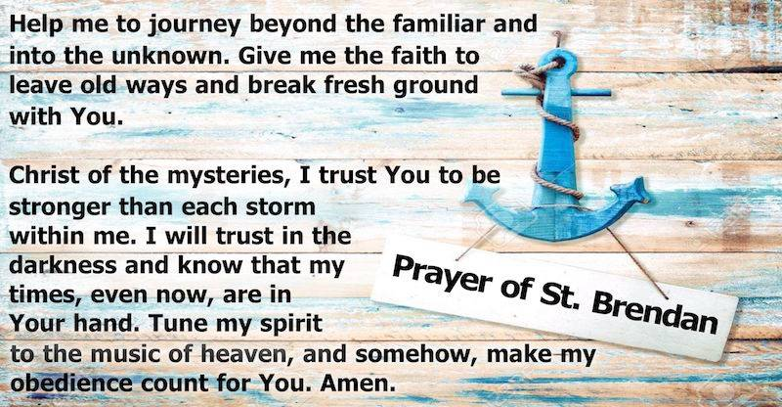

This year the students and staff will attend the 10am mass on the 20th May at St Mary’s Colac, to celebrate the feast of St Brendan. We invite you all to join us as we share the story of St Brendan.

Invitation to the The Catholic Diocese of Ballarat Pre-Synodal Celebration Synod of Bishops 2021 -2023
Bishop Paul Bird will celebrate Mass to acknowledge the conclusion of the first phase of the Synodal process on Sunday, May 15, 2022 at 10.30am in St Patrick’s Cathedral Ballarat. All people of the diocese are welcome to attend.

Welcome
Parish of Cororooke
727 Corangamite Lake Ro
Coragulac, VIC 3249
Email: cororooke@ballarat.catholic.org.au
Moderator: Maureen Finn 0428329231
Supervising Priest: Fr Michael O’Toole
School Principal: Leanne Eastman
Parish Sec: Gracesyn Perrett 52331464
Child Safety Officer: Leanne Eastman
St Brendan’s: 9.30am Sunday/
5pm 4th Sunday
St Joseph’s: 10:30am Lay-led /
Mass 1st Sunday

St Brendan’s:22nd May, Mass @ 5.00pm
Minister: M Allan
Commentator: L Darcy
Reader: M Gorwell

St Joseph’s: No Service Mass at St Brendan’s

ALTAR & SACRISTY DUTIES: May
St Brendan’s: H Holland & J O’Dowd
St Joseph’s: A Convery & A Oborne

Counters: 8th May: L Darcy
22nd May: J Miller

RECENT DEATHS: Colin Boyd, Tyson Hodge, Billy Boylan, Derry Craig & John Ryan (cousin of J Miller)

ANNIVERSARIES: Norma Clifford, Kathleen Denning, Margaret O’Sullivan, Marie McKay, Margaret Sherman,
Tony Sproules

Those seeking our prayers for
healing and well being.
Leah Spokes, Geraldine Finn,
Goldie Elsum, Doug Swanson.

Mass Counts start on weekend 7-8 May
The Annual Diocesan Mass Count will take place over 4 weekends in May. Counting will start on 7-8 May and continue each weekend until the end of May. Please record a count for every Mass and Lay Led Assembly held in your parish on each of the four weekends.
Pope’s intention for May:
For faith-filled young people: We pray for all young people, called to live life to the fullest. May they see in Mary’s life the way to listen, the depth of discernment, the courage that faith generates and the dedication to service.

PARISH LEADERSHIP TEAM: Meeting 19th May@5pm

National Family Week: May 15-21, 2022
CatholicCare Victoria believes that building strong family relationships is the key to building healthy, resilient communities. Strong families give children the foundation they need to grow and the support they need to face challenges and setbacks not only now, but into the future. So how can parents and families build strong family relationships? Family Relationship Practitioners in Bendigo, Julia Feiss and Lisa Castles, share five important elements for creating strong families at https://www.catholiccarevic.org.au/news/247/a-blessing-for-families.

Prayer for the Family
Jesus, Mary and Joseph,
in you we contemplate
the splendour of true love,
to you we turn with trust.

Holy Family of Nazareth,
grant that our families too
may be places of communion and prayer,
authentic schools of the Gospel
and small domestic Churches.

Holy Family of Nazareth,
may families never again
experience violence, rejection and division:
may all who have been hurt or scandalized
find ready comfort and healing.

Holy Family of Nazareth,
may the approaching Synod of Bishops
make us once more mindful
of the sacredness and inviolability of the family,
and its beauty in God’s plan.

Jesus, Mary and Joseph,
graciously hear our prayer.

Given by Pope Francis on the Feast of the Holy Family of Nazareth, Saint Peter's Square, Sunday, 29 December 2013

Prayer for Ukraine
God of peace and justice,
We pray for the people of Ukraine.
We pray for peace and the
laying down of weapons.
We pray for all those who fear for tomorrow,
That your Spirit of comfort would
draw near to them.
We pray for those with power of war or peace,
for wisdom, discernment and compassion
to guide their decisions.
Above all, we pray for all your
precious children, at risk and in fear,
that you would hold and protect them.
We pray in the name of Jesus,
the Prince of Peace. Amen

Laudato Si’ Week: May 16-24, 2022
• As part of Catholic Earthcare’s celebration of Laudato Si’ Week, they are hosting an online screening of the newly released 'Regenerating Australia' short film - a fictitious news segment set on New Year’s Eve 2029, examining the decade that 'could be'. The film challenges people to consider how to respond to the Cry of the Earth. Participants will be joined by Bishop Ken Howell and a range of guest speakers to share in this celebration. After the film, there will be a panel discussion and question time regarding how we can take the teachings of the film and respond as Catholics here in Australia. You are welcome to join by yourself or register a parish group for the viewing (please note if registering for a group, only one person need register via Trybooking). The video will be streamed via zoom so you can watch together on a large screen at a suitable venue like a parish hall. The online event will be held on Tuesday, May 17, 2022 from 6.00pm – 8.00pm AEST, 4.00pm – 6.00pm AWST. Bookings at: https://www.trybooking.com/BZADT. Letter and invitation attached.
• Also celebrating Laudato Si’ Week 2022, the Office for Justice, Peace and Ecology (Australian Catholic Bishops Conference) have daily Reflection Sheets that can be downloaded at https://socialjustice.catholic.org.au/2022/03/21/laudato-si-week-resources/

Daily Gospel Reflections
During the height of COVID in 2020, the Archdiocese of Brisbane’s Adult Formation Team launched a daily gospel reflection resource to help Catholics stay connected with God whilst they couldn’t attend Mass. The resource has been so well received that the offer is extended to all who may find it useful. The Daily Gospel Reflections are delivered each weekday morning to your email inbox, and will take just a few moments to read but will centre you in relationship with God for the rest of the day. To find out more or subscribe go to https://evangelisationbrisbane.org.au/daily-reflections/

Study Teaching Meditation and Prayer online
This unit develops the skills to teach meditation and prayer in a variety of contexts. It will consider the spiritual life across the lifespan and meditation methods appropriate for various age groups including children, teenagers and adults in contemporary context. Sessions will be online via zoom over four Saturdays from 10.00am – 4.30pm: June 18 & 25 and October 8 & 15. Contact the Academic Records Office for more information and enrolment appointments, ph. 03 9412 3314 or email jenny.delahunt@ctc.edu.au or go to https://units.divinity.edu.au/scheduled-unit/DS9611C-6304

