Recent Deaths: Fr Robert Stickland - who was the brother of Fr Barry Stickland, was a married, Ukranian Catholic Priest in Melbourne who died suddenly last week. Father Barry’s sister Denise, is still living in Beaufort.
Sick: Susan O’Sullivan, Chris Burns, Joan Bathgate, Terri Scott, Mark Weir, Cate Poynton, Josephine Sciberras and Laura Burns.
May our healing God touch the lives of our sick bringing them comfort & peace.
Sunday 1st August – Assembly – Wk 1
Ouyen: 9:00 am
Reader: John Nihill
Prayers of the Faithful: Carmel Vallance
Eucharistic Minister: John Galvin
Leader: Flora Moulder

Sunday 8th August – Assembly – Wk 2
Ouyen: 11:00 am
Reader: Peter Shaddock
Prayers of the Faithful: Marie Shaddock
Offertory Procession: Flora Moulder & Jona Kilaton
Projectionist: Louise Fitzpatrick Leach

Collections: 11. 7. 2021

Patche: $45.00

Ouyen: $267.00

Planned Giving: $197.00

Church Cleaning:

July – The Grace Family

Presbytery Cleaning:

July – Faye Nihill
Sacrament of Reconciliation:
After Mass (11:45am) on the 2nd & 4th Sundays of the month, and of a Thursday afternoon during and after Adoration and or Mass (in consultation with Father) or at any other time by appointment with Father.

Adoration of the Blessed Sacrament: Thursdays 2:00pm – 5:00 pm, usually followed by Mass; all welcome.
St Joseph’s Parish New Mass Timetable
Wk 1 Patche Mass 10:00am 1stFriday
Ouyen Assembly 9:00am Sunday
Wk 2 Ouyen Mass 11:00am Sunday
Wk 3 Ouyen Mass 8:30am Sunday
Wk 4 Ouyen Mass 11:00am Sunday
U’Bool Mass 3:00pm Sunday
Wk 5 Ouyen Mass 11:00am Sunday
Sadly, we are still unable to go to Mass due to the lockdown, but we hope that by the following week, the 1st of August which should be a Lay Led Assembly, we will be able to return to the church – although it may be with some restrictions in place. If this is not the case, and we are still in lockdown, then we will begin to stream the Mass again from our church. In the meantime, you can watch the Mass online from the new Wimmera-Mallee parish (Horsham), https://www.facebook.com/groups/290128528634743/ Also Our diocesan website has information about links to online Masses and other prayer resources at https://www.ballarat.catholic.org.au/ coronavirus-the-churchs-information-and-advice-2/#links-to-masses-online
If you have any concerns or questions please phone: 0417660893 (Marie)
Special Prayers have been asked for Terri Scott who has had an unexpected surgery this last week. Let us keep her and all the family in our prayers.
Note from Father Anthony: Dear Parishioners,
As we are in the extension of a snap lockdown, I pray for strength, light and hope for everyone. In these times we realise more and more that we are not alone. The Lord is with us! We are all spiritually united through our prayer for one another. May our faith, hope and love be a source of strength and encouragement.
I remember you all in my daily private Masses and prayers. I look forward to meeting you again after the lockdown at the parish Mass. May St Joseph teach each of us to place our trust in God, praying for patience peace and healing. May the Lord be close to you and bless you and your families. Fr Anthony Nagothu.
An answer to our prayers: On the 18th of July Bishop Paul was to install Bill Lowry and Matt Restall, both 6th year seminarians for the Diocese of Ballarat, as candidates for ordination. Bishop Paul was also to install Cay Trinh in the ministry of Acolyte. Cay, is from Vietnam, and is a fourth year seminarian for our Diocese. Unfortunately, this didn’t happen but it will as soon as we are able to return to Mass. In the meantime, let us thank God that our prayers for more seminarians are being heard and answered and please continue to pray for them and for more to come!

The Seventeenth Sunday in Ordinary Time
Reflections from Scott Hahn . . .
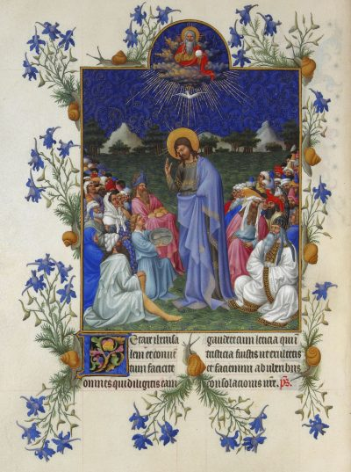
Today’s liturgy brings together several strands of Old Testament expectation to reveal Jesus as Israel’s promised Messiah and King, the Lord who comes to feed His people.
Notice the parallels between today’s Gospel and First Reading. Both Elisha and Jesus face a crowd of hungry people with only a few “barley” loaves. We hear similar words about how impossible it will be to feed the crowd with so little. And in both the miraculous multiplication of bread satisfies the hungry and leaves food left over.
The Elisha story looks back to Moses, the prophet who fed God’s people in the wilderness. Moses prophesied that God would send a prophet like him. The crowd in today’s Gospel, witnessing His miracle, identifies Jesus as that prophet.
The Gospel today again shows Jesus to be the Lord, the good shepherd, who makes His people lie down on green grass and spreads a table before them. The miraculous feeding is a sign that God has begun to fulfill His promise, which we sing of in today’s Psalm—to give His people food in due season and satisfy their desire. But Jesus points to the final fulfillment of that promise in the Eucharist. He does the same things He does at the Last Supper—He takes the loaves, pronounces a blessing of thanksgiving (literally, “eucharist”), and gives the bread to the people. Notice, too, that twelve baskets of bread are left over, one for each of the Apostles/the Twelve Tribes of Israel.
These are signs that should point us to the Eucharist—in which the Church founded on the Apostles continues to feed us with the living bread of His Body. In this Eucharist, we are made one Body with the Lord, as we hear in today’s Epistle. Let us resolve again, then, to live lives worthy of such a great calling

This Week’s Plenary Council Reflection: From the Gospel: ‘‘Then Jesus took the loaves, gave thanks, and gave them out. . . ’ “The Eucharist, although it is the fullness of sacramental life, is not a prize for the perfect but a powerful medicine and nourishment for the weak.” (Evangelii Gaudium, 47). Is that how we view the Eucharist, do we value it, do we need to start afresh? This week especially, while we are deprived of being at Mass, let us think about the role of the Jesus in the Eucharist in our lives and what God is saying to me about it. The first session of the Plenary Council is drawing closer, please continue to pray for all involved and that the Holy Spirit, who is the guide of the Church, will be listened to and followed.
Inspiration from the Saints: “Look upon yourself as a tree planted by the water, which bears its fruit in due season. The more the wind blows, the deeper it strikes its roots into the ground.” St Margaret Mary Alacoque - a French Visitation nun and mystic, who promoted devotion to the Sacred Heart of Jesus

Send your Holy Spirit upon them to be their Helper and Guide!
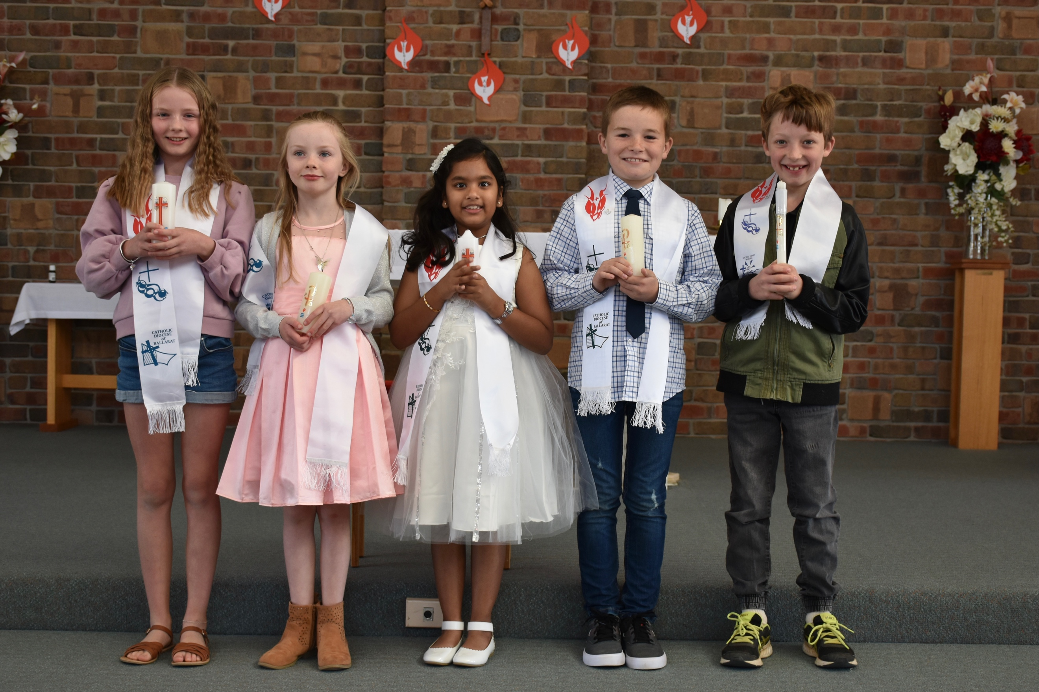

Congratulations to: Chloe Brady, Matilda Brady, Ann Bosco, George Scott & Nigel Hamilton who were recently confirmed. Many thanks to Fr Anthony and all who took part, it was a great success.

