Recent Deaths:

Anniversaries:
Sick: Susan O’Sullivan, Chris Burns, Joan Bathgate, Terri Scott, Mark Weir, Cate Poynton, Josephine Sciberras and Laura Burns.
May our healing God touch the lives of our sick bringing them comfort & peace.
Sunday 25th July – Mass – Wk 4
Ouyen: 11:00 am
U’bool: 3:00pm
Reader: Marie Shaddock
Prayers of the Faithful: Peter Shaddock
Offertory Procession: John & Merril Boland
Projectionist: Marie Shaddock

Sunday 1st August – Assembly – Wk 1
Ouyen: 9:00 am
Reader: John Nihill
Prayers of the Faithful: Carmel Vallance
Eucharistic Minister: John Galvin
Leader: Flora Moulder

Collections: 11. 7. 2021

Patche: $45.00

Ouyen: $267.00

Planned Giving: $197.00

Church Cleaning:

July – The Grace Family

Presbytery Cleaning:

July – Faye Nihill
Sacrament of Reconciliation:
After Mass (11:45am) on the 2nd & 4th Sundays of the month, and of a Thursday afternoon during and after Adoration and or Mass (in consultation with Father) or at any other time by appointment with Father.

Adoration of the Blessed Sacrament: Thursdays 2:00pm – 5:00 pm, usually followed by Mass; all welcome.
St Joseph’s Parish New Mass Timetable
Wk 1 Patche Mass 10:00am 1stFriday
Ouyen Assembly 9:00am Sunday
Wk 2 Ouyen Mass 11:00am Sunday
Wk 3 Ouyen Mass 8:30am Sunday
Wk 4 Ouyen Mass 11:00am Sunday
U’Bool Mass 3:00pm Sunday
Wk 5 Ouyen Mass 11:00am Sunday

Due to the Latest Lockdown there will be No Mass this Sunday. It would seem that the government also want us to “Come away by ourselves and rest for a while”
QR Codes & the new Regulations: Under the Victorian Government COVID regulations all venues must now use the QR code provided. Manual sign-in sheets are now no longer allowed unless, absolutely essential. We will have volunteers to help you sign in. Please arrive at least 10 minutes early to help us register you in this way.
Thursday Mass – resumes this week at 5:00pm, all being well!
Hopefully Next Sunday July 25th, at the 10.30am Cathedral Mass, Bishop Paul will install Bill Lowry and Matt Restall, both 6th year seminarians for the Diocese of Ballarat, as candidates for ordination. Bishop Paul will also install Cay Trinh in the ministry of Acolyte. Cay, is from Vietnam, and is a fourth year seminarian for our Diocese. Please continue to pray for our seminarians and for more to come.

Next Sunday, July 25th is World Day for Grandparents & the Elderly. After the changes and turmoil brought by Covid, it is timely that we now look to how we acknowledge and honour the gifts of age and the continued mission of our older people as holy faithful People of God. It is hoped that this is a way to connect all generations and give concrete expression to our pastoral concern and respect for older people. It should also be a time when each of us are encouraged to reach out to family, friends, neighbours, the aged, the lonely, and the sick, with the heart of the Gospel words “I am with you always.”
Australian Catholic Men's Gathering 2021
As an initiative of the Australian Catholic Bishops, the National Catholic Men’s Gathering aims to inspire and encourage all men with a vision for personal discipleship, service and mission in the family, parish/diocese and the world. The online program hopes to reinforce that it is important to gather as men in the faith environment of the Church. This is a free event for those registered, all available from Saturday, July 31, 2021. To read about this year's speakers and more go to https://www.nce.catholic.org.au/catholicmen
The Sixteenth Sunday in Ordinary Time
Reflections from Scott Hahn . . .
As the Twelve return from their first missionary journey in today’s Gospel, our readings continue to reflect on the authority and mission of the Church.
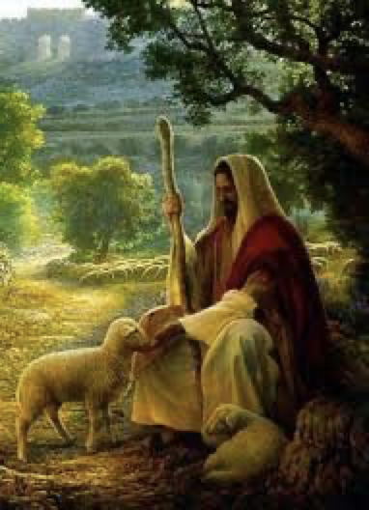
Jeremiah says in the First Reading that Israel’s leaders, through godlessness and fanciful teachings, had misled and scattered God’s people. He promises God will send a shepherd, a king and son of David, to gather the lost sheep and appoint for them new shepherds.
The crowd gathering on the green grass in today’s Gospel is the start of the remnant that Jeremiah promised would be brought back to the meadow of Israel. The people seem to sense that Jesus is the Lord, the good shepherd, the king they’ve been waiting for. Jesus is moved to pity, seeing them as sheep without a shepherd. This phrase was used by Moses to describe Israel’s need for a shepherd to succeed him. And as Moses appointed Joshua, Jesus appointed the Twelve to continue shepherding His people on earth.
Jesus had said there were other sheep who did not belong to Israel’s fold but would hear His voice and be joined to the one flock of the one shepherd. In God’s plan, the Church is to seek out first the lost sheep of the house of Israel and then to bring all nations into the fold.
Paul, too, in today’s Epistle, sees the Church as a new creation, in which those nations who were once far off from God are joined as “one new person” with the children of Israel. As we sing in today’s Psalm, through the Church, the Lord, our good shepherd, still leads people to the green pastures of the kingdom, to the restful waters of baptism; He still anoints with the oil of confirmation, and spreads the Eucharistic table before all people, filling their cups to overflowing. This Sundays Gospel also reminds us of the teaching ministry of the Church, and gives encouragement to everyone involved in Catholic education. Let us pray for them all, that they too are good shepherd.

Weekly Plenary Council Reflection:
As the first session of the Plenary Councils draws ever closer, please continue to pray for all involved and that the Holy Spirit, who is the guide of the Church, will be listened to and followed. This weeks reflection, is from the Gospel of St Mark: ‘You must come away all by yourselves and rest for a while. . . ’ The journey of holiness into ever fuller communion of life with God and others is impossible without growth in the practices of the spiritual life, of inner stillness, active listening, reflective reading . . . How do we do that?

Send your Holy spirit upon them to be their Helper and Guide!
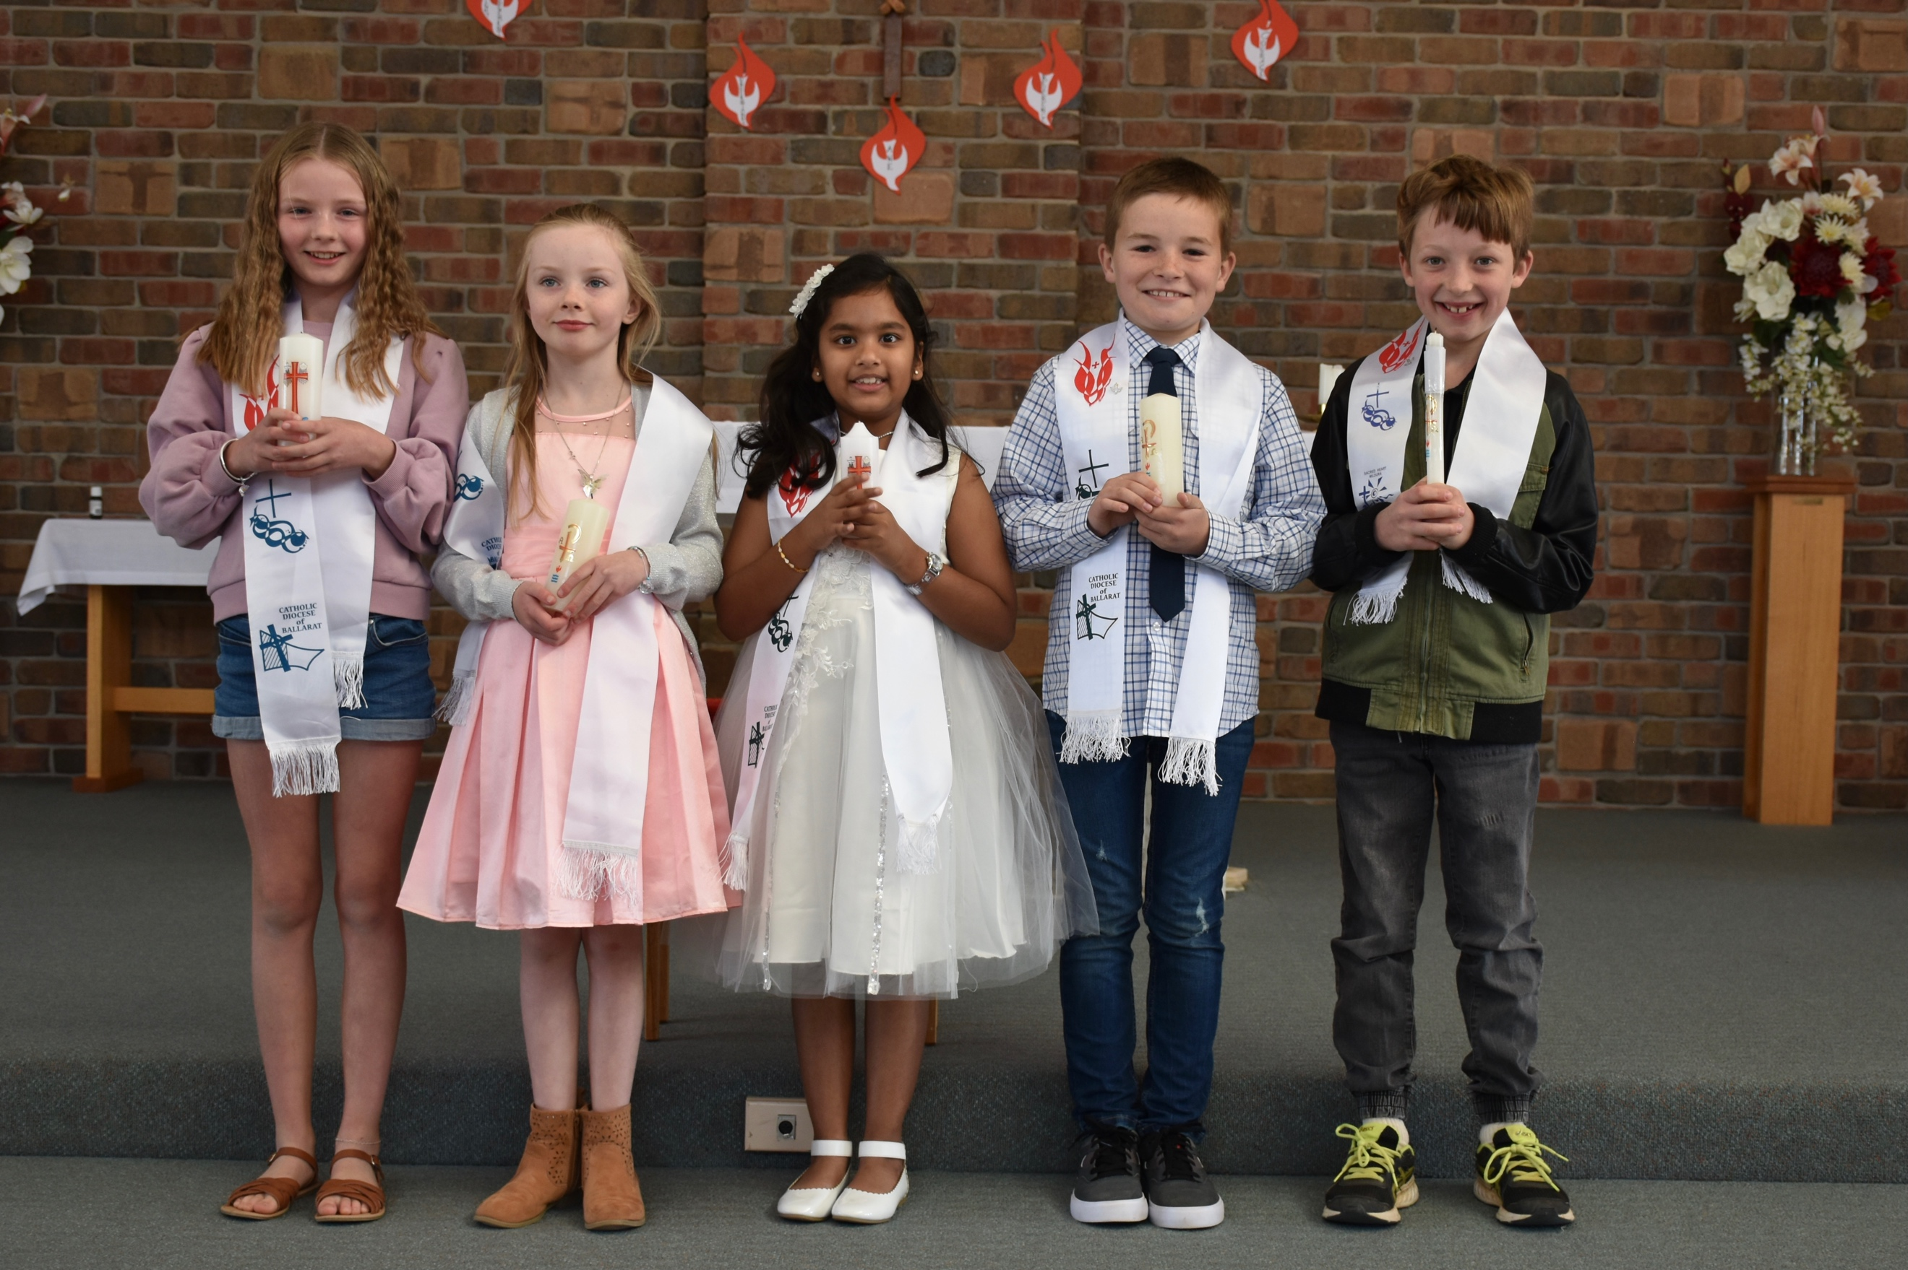

Congratulations to: Chloe Brady, Matilda Brady, Ann Bosco, George Scott & Nigel Hamilton who were confirmed last weekend. Many thanks to Fr Anthony and all who took part, it was a great success.

