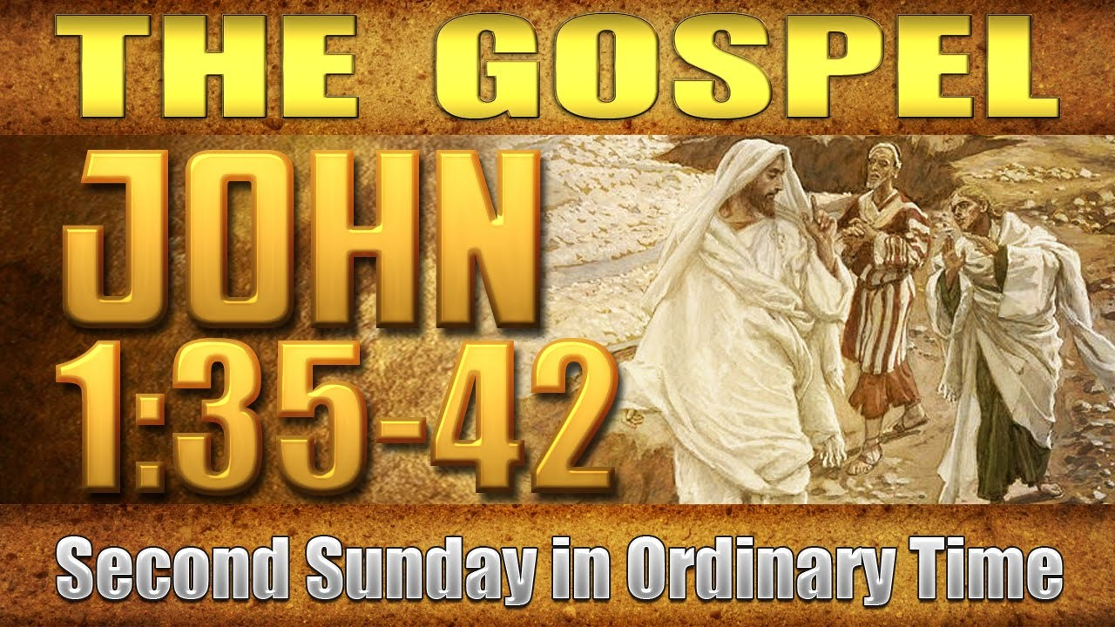
St Peter’s Parish

Linton, Skipton, Smythesdale, Snake Valley
Please Contact the Cathedral Office
5331 2933

ballarat@ballarat.catholic.org.au

Parish Office: Jacinta Westbrook,
Priests: Frs Justin Driscoll, Anthony Nagothu, Sajan Mathew
Sunday 14
^{th}
January 2018

Recent Deaths: Mary Davey, Damian Dignan, Gary Hall, Una Harrington,
Brian Mahar, Patrick Moran

Anniversaries: Peter Bassett, Marlene Dobbyn (Smythe), Gerard Dumaresq,
Gertrude Feldgrill, Frank Godfrey, Tony Houlihan,
Naeidra Layton, Catherine Maher, Joseph Maher,
Mary McGuiness, Sr Joan D’Orsa, Michael Rowdon, Glen Taffe, David Torpy

Please remember in your prayers those who are unwell, especially
Athanasius Casanova, Margaret Cranko, Nic Gowans, Nancy Hand, Grace Molloy, Kerrie Mulcahy, Marie Stevens, Milly Yeoman

Next week’s readings: Sunday 21^{s} January 2017 3rd Sunday in Ordinary Time (B)
Jonah 3:1-5.10 Ps 24:4-9. R. v.4 1 Corinthians 7:29-31 Mark 1:14-20

Masses: 20th/21st January 6.30 pm Smythesdale 9.00 am Skipton
10.30 am Rokewood
Australia Day 10.00 am St Patrick’s Cathedral Ballarat
27th/28th January 6.30 pm Snake Valley 8.30 am Beaufort
10.30 am Skipton

Year of Youth
Resources from ACBC are now available. Topics include No Young People in m
Parish, A Guide to Listening Forums and New Horizons Series. Find them under Year of Youth on the Youth and Young Adult Ministry page of the diocesan website: www.ballarat.catholic.org.au/services-and-agencies
Seeking a Diocesan Youth and Young Adult Project Worker
Ballarat Diocese will be employing a Project Worker in Youth and Young Adult Ministry in 2018, the Year of Youth. This will be a 12 month position, fulltime preferred but not essential. A position description will be available on the diocesan website in January or you can contact youth@ballarat.catholic.org.au to have the position description emailed to you.

23rd Organs of the Goldfields Festival
On Sunday January 14th the Cathedral’s Fincham organ of 1930 is played by Martin Setchell in the Cathedral at 3.00 pm. On Wednesday January 17th Eine
Abendmusik. John Weretka directs a re-creation of the traditional German
Advent Cantata Concert as heard in the early 18th century. Singers, Helen
Thomson, Amelia Jones, Hamish Gould, Christopher Roache and John Weretka. The festival will close on Sunday January 21st Baroque Sacred Music The Missa Salisburgenis of Heinrich Biber. Bringing together two University choirs, Queens & Newman and using the spatial properties of the Cathedral.
Directed by Gary Ekkel.
Catholic Social Services National Conference “Hearing Healing Hope”
The 2018 Catholic social services national conference, Hearing Healing Hope (Melbourne, February 21st – 23rd 2018) provides an opportunity to reflect on the major issues that affect our communities of concern, our Catholic social service organisations, our parishes and ourselves as leaders. Workshops will focus on NDIS, housing, governance issues, Indigenous engagement, parishes and service, caring for vulnerable clients and family violence. For more information and bookings, go to: www.css.org.au

