“See Me, Hear Me” Poster Competition

Where I feel safe,
When I feel safe,
Who makes me feel safe,
What am I doing when I feel safe.
Who makes me feel safe,
What am I doing when I feel safe.

Research undertaken with children and young people regarding their experiences in organisations naturally tell us that feeling safe is important to them. What is equally significant to this is that children have their own ideas about what makes them safe. To this end, they themselves need to be seen and heard.

The Diocese/Parish/Youth group/community of, (insert name) is running a poster competition to provide one opportunity for the children and young people to express an opinion about what makes them safe.

The theme of the poster is “See Me, Hear Me” having a focus on the positive dimensions of where, when, or what am I doing when I feel safe.

It is not encouraged that children should illustrate when they are feeling unsafe. This, however may occur and strategies are in place to respond to the young person or child.

Possible guide to running the competition:

Organising group

Across the Diocese, parishes, school or community groups perhaps have a volunteer or a small group of volunteers to assist with the administration, such as collecting entries, ensuring the child’s name and age are documented on the other side of all entries and passing entries onto your judging panel

Decide whether you will have age Groups

Possibly organise into age groups for the entries

- 5 years to 12 years of age
- Over 12 years of age

Decide on time span for competition to run

The competition is open from (insert date)
The competition closes (insert date) or Simply a deadline

Is it your preference that the competition has prizes or just provides an opportunity for the participants to share their posters?

Choose an occasion when winners could be announced and prizes awarded or a time when the participants share in their thoughts.
If running a competition consider possible prizes such as iTune vouchers, movie passes, vouchers for theme parks or other children’s entertainment venues, book vouchers, red balloon experiences etc.

Agree on a process on how to enter, for example
- design a poster A4 in size around the theme; “Hear Me, See Me” the poster could depict the following
Where you feel safe,
when you feel safe,
who makes me feel safe or
what am I doing when I feel safe
- Decide on the form – painting, drawing, graphic design, web page etc
- Positive images

How best to promote?

Adapt and use the attached front cover, photocopy and distribute via relevant groups, bulletins, social media, etc asking children and young people to use their artistic talents to design the poster for Child Protection Week.

How will the posters be collected?

Decide whether they will be collected or sent in via digital photo. Where will they be collected, or provide a specific subject name for digital collection.

Possible Terms and Conditions for a competition

Entries commence on (insert date) and close on (insert date). Entry is open to children of the (insert name) aged between 5 – 12 years and 13 – 16 years. You may enter in only one age bracket, but you may submit more than one entry. The entry needs to be original, drawn and designed by the child entering the competition, no parental work may be entered into the competition. (insert name) will have a judging panel of no more than 3 people and the winner in each age bracket will be by majority vote. Prizes, announcements of winners and presentation of prizes may vary between groups and be appropriate to activities running at the time.
The prizes will be supplied by (insert name) and the winner will be announced ……….

Strategies in place should a child disclose

It is suggested that your normal reporting procedures need to be operational should a child disclose any abuse. It would be important to discuss the importance of the ‘feeling safe’ theme of the competition with the organising group

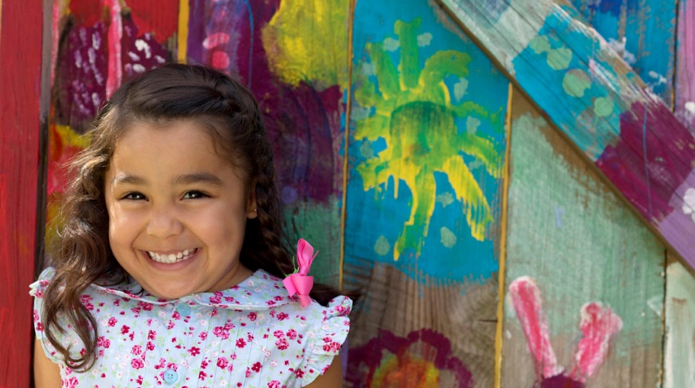
With thanks to the NSW – ACT Chanceries Professional Standards group for their initial suggestion and provision of competition ideas

