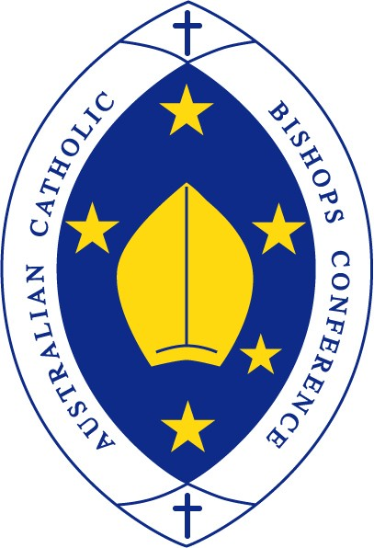
Australian Catholic Bishops Conference

Pope urges faithful to respond to the “cry of the poor”

Media Release | October 26, 2018
In his message for the second World Day of the Poor, Pope Francis has called for a new evangelisation that prompts Catholics “to make tangible the Church’s response to the cry of the poor”.

In a letter to clergy throughout Australia, Bishops Commission for Pastoral Life chairman Bishop Terence Brady encouraged all Catholic communities to be involved and respond to the theme of day: “This poor man cried and the Lord heard him” (Psalm 34:7).

The World Day of the Poor will be celebrated this year on November 18.

“The Holy Father notes that there are many different forms of poverty and he asks us to consider ‘Who are the poor?’,” Bishop Brady said.

“He describes how we only recognise the voice of the poor in silence and then, having listened, we must answer. Our response, he suggests, calls for a ‘loving attentiveness which honours the person … and seeks out his/her best interests’.”

Pope Francis inaugurated the World Day of the Poor at the end of the Jubilee Year of Mercy in 2016. The Pope’s 2018 message was signed on the feast day of St Anthony of Padua (June 13), the patron of the poor.

Pope Francis said: “The World Day of the Poor wishes to be a small answer that the Church throughout the world gives to the poor of every kind and in every land, lest they think that their cry has gone unheard.

“Often I am afraid that many initiatives, by themselves meritorious and necessary, are intended more to please those who undertake them than to really acknowledge the cry of the poor.

“We are so entrapped in a culture which obliges us to look in the mirror and to pamper ourselves that we believe that a gesture of altruism is sufficient without compromising ourselves directly.”

Pope Francis explained poverty “is not brought on by itself, but is caused by selfishness, pride, greed and injustice”.

“Each individual Christian and every community is called to be an instrument of God for the liberation and promotion of the poor, and for enabling them to be fully a part of society,” he said.

“In order to overcome the overwhelming condition of poverty, it is necessary that the poor perceive the presence of brothers and sisters who show concern for them and who, by opening the door of their hearts and lives, make them feel like friends and family.”

Bishop Brady said Pope Francis invites us to make concrete the words of the Psalm 22:27: “That the afflicted shall eat and be satisfied.”

“His message contains a very practical suggestion: the sharing of the Sunday meal with the poor,” Bishop Brady suggested.

“I encourage you to sow the seed of this idea, inviting parishioners and the homeless to share a meal after Mass on or around November 18, as the Pope calls us to celebrate in the spirit of joy for the rediscovery of our capacity for getting together, stating that ‘Praying together as a community and sharing a Sunday meal is an experience which takes us back to the earliest Christian community’.”

The Holy Father has invited “priests, and in particular deacons, on whom hands have been laid for the service of the poor (Acts 6: 1-7), as well as religious and the lay faithful – men and women – who in parishes, associations and ecclesial movements make tangible the Church’s response to the cry of the poor, to live this World Day as a special moment of new evangelisation”.

Pope Francis concluded his message by saying that “the cry of the poor is also a cry of hope which manifests the certainty of being liberated”.

Click here to access Pope Francis’ message for the World Day of the Poor.

