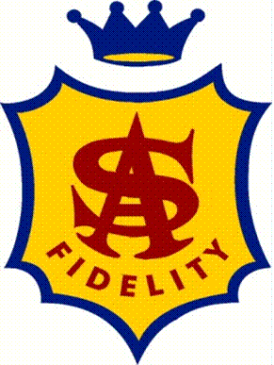
St Aloysius Parish
Family Based – Parish Coordinated – School supported Sacramental Program

Registration Form
Family Surname________________________ Child’s Name ________________
Child’s Date of Birth ___/___/____ School: ___________________________
Home Address____________________________________________________
Telephone (H)___________________ (M)________________________
Email____________________________________________________________
Parent details: Mother’s Name________________ Religion________________
Mother’s maiden name _____________________
Father’s name_________________ Religion________________
Date of Child’s baptism ___/___/____
Place of Baptism (name of church and location) _________________________
Certificate sighted _______
Please bring to the meeting your child’s Tri Fold Certificate or a copy of your child’s Baptism certificate if they we not Baptised in the Ballarat Diocese
PROGRAM ENROLMENT DETAILS
OFFICE USE ONLY | Program | Enrolment date | Fee Paid ($25 per program | Received by | Tri – Fold Required | Stole Required
 | Confirmation
 | Reconciliation
 | First Eucharist

Parent or Guardian who will be supporting this child in the Sacramental Programs
Name______________________ Signature _________________________

