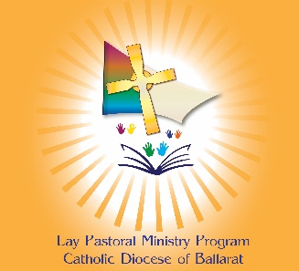
Diocese of Ballarat
Lay Pastoral Ministry Program
Application Form

Date of Application ………./………./……….
Family Name: Given Name/s: Male Female
Address:
Phone: Mobile:
Email:
Your Parish:
Referees
Parish Priest: Contact phone number:
Or
Other: Contact phone number:

Academic qualifications [if applicable]
Any previous study:
Highest award achieved: Year:
Current study [if applicable]:
How did you hear about the Lay Ministry Pastoral Program?
Parish Website Friend Other
Do you have a Working with Children Check or Teachers VIT? YES/NO
NB: WWCC is not required to undertake these studies. A WWCC is required if you are volunteering in your Parish. If you do not hold one please contact your Parish to apply for a free Volunteer WWCC.
Your Story (box will expand to fit your response)
What has moved you to apply for the Lay Pastoral Ministry Program?

Describe your current role in service or ministry in your parish or community

Are you baptised YES / NO Have you received Confirmation in the Catholic Church? YES / NO
The Lay Pastoral Ministry Program offers the opportunity to study individual subject/s or study six subjects to complete a Certificate course. A Certificate should be completed within two years. Those who choose to start with individual subjects may transfer to a Certificate course. Completion of subject/s or Certificate, together with associated participation in local formation gatherings, will be certified by the Diocese.
PLEASE INDICATE BELOW IF YOU INTEND TO STUDY A CERTIFICATE OR INDIVIDUAL SUBJECTS
(contact us to discuss if needed)
Certificate courses: (list individual subjects if know)
Certificate in Pastoral Ministry | Certificate in Youth and Young Adult Ministry
Subjects: | Subjects:
Individual subject/s: (List individual subjects if known)

I am over 18 and have read the information on the Ballarat Diocese website regarding the Lay Pastoral Ministry Program and understand the work and study commitment. Please tick.

Please email completed form to: djurdja.klaric@ballarat.catholic.org.au
All information is treated in accordance with the Diocesan Privacy Policy, available on the Diocesan website.

