MAKING A SCENE AT CHRISTMAS
at
Bridge Mall
Saturday December 3
Saturday December 10 – Friday December 23, 2022

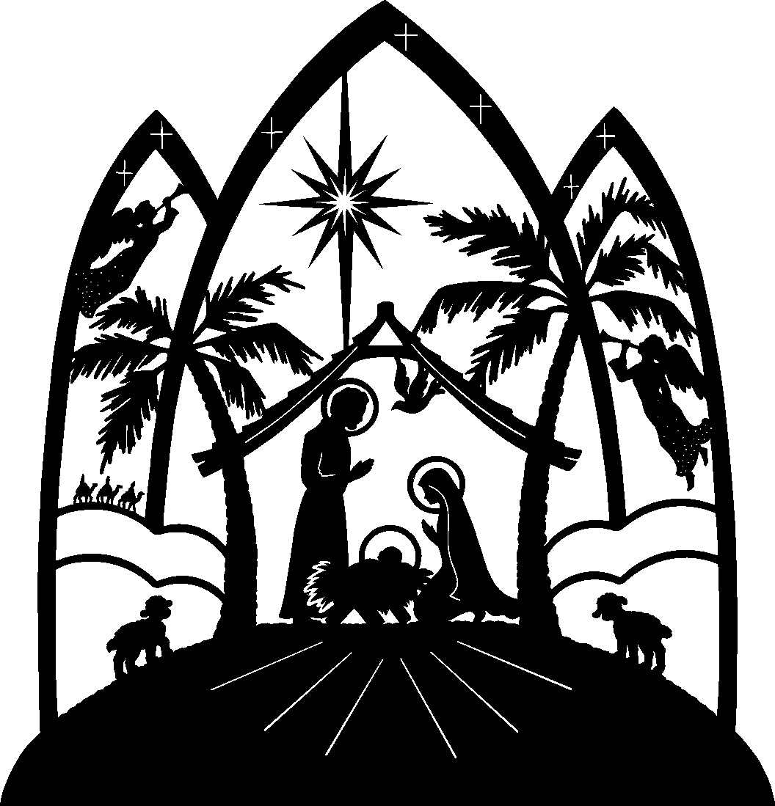

MAKING A SCENE AT CHRISTMAS
is a display of over 500 Christmas Nativities from more than 60 countries.
You can - see and smell real frankincense and myrrh;
- see coins minted around the time the census was called that brought Joseph and Mary to Bethlehem; and

- see hand crafted cultural nativities from Australia, Africa, Asia, North & South America, & Europe (and one that went to Antarctica)

- Nativities that prize social justice and the environment

Entry is a gold coin donation. Every one welcome.

