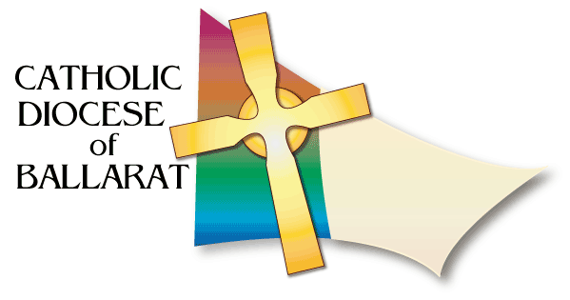
DIOCESAN LITURGICAL COMMISSION
FUNERAL MINISTRY RESOURCES

EULOGY WRITING - QUICK TIPS
The term eulogy sounds stiff and formal, but eulogies can include simple reminiscences and stories. Perhaps a better term might be “Words of Remembrance”. Here's how to put it together:
1. Gather your material
First, collect the biographical facts - age, marriage dates, places lived, children and so on. Now think about the stories you remember, or the turn of phrase or typical behaviour that captures your loved one's character so well. Talk with other family, so the picture you present will include their ideas as well.
2. Come up with a theme
A theme gives unity to the eulogy, helping your listeners to see the rich patterns of this life. For example, let's say you are giving the eulogy for your late mother. As your theme, you decide to talk about your mother's ability to make a home wherever she hung her hat.
Another example: When speaking of a friend, you might mention the various roles your friend successfully played, ie. the businessman, the family man, etc.
3. Organise the material
Write your notes in point form on sheets of paper or on 3x5 file cards - one idea to a card. Group the cards into piles of similar topics and then sort each pile of cards into a logical order.
4. Draft your speech
Write out the first draft (if you have access to a computer, use it to make your editing job easier). Use linking sentences to make each topic flow easily into the next. Pay most attention to the beginning and ending.
As you write and polish, keep the words "celebration" and "thanksgiving" in your mind.
The Words of Remembrance should be 5-7 minutes and certainly no longer. Your words should be straight to the point.

