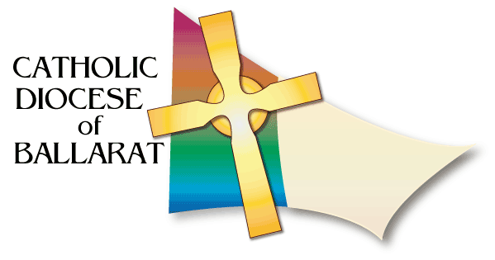
DIOCESAN LITURGICAL COMMISSION
FUNERAL MINISTRY RESOURCES

THE PALL
If we listen carefully to the texts used at a funeral liturgy, we discover that there are several references made to the baptism of the person who is now deceased.
To emphasise the importance of the person's baptism, the Church in Australia encourages the use of a pall at the funeral liturgy. This pall is placed on the coffin during the rite of reception of the body by family members, friends or by parish ministers.
This pall is a reminder of the white baptismal garment, a sign of the Christian dignity of the person. Just as the new Christian was clothed in the white garment when he or she became a member of the Church, the coffin is covered with a white cloth as the person enters into a new life in the resurrection of Jesus. Covering the coffin is a way to make a statement about the identity of the deceased; it proclaims that the greatest thing that can be said about the deceased person is that he or she is a sister or brother of Christ, a member of the Church.
The pall is also a sign of hope, of the resurrection, of new life beyond this life, a banner that points to a continued relationship to the deceased person in the time to come. Its use also signifies that in the eyes of God all are equal (Order of Christian Funerals, no. 38).
The Pall should be removed at the end of Final Commendation (and placed over the front seat).
THE FLAG
When persons who are or were in the military die, family and friends often wish to display the (national) flag as a symbol of national service. They want to drape the flag over the coffin, as is the custom at a "military" funeral. For Catholics, however, baptism remains the fundamental identity. Other emblems should not displace Christian symbols reminding the community of the person's baptism.
The pall will be removed after the liturgy, and the flag can again be placed on the coffin as it is being transported out of the church.

