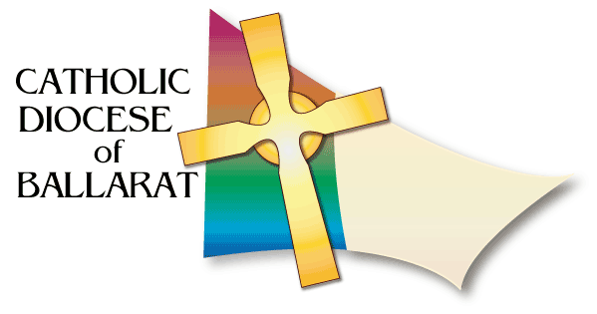
DIOCESAN LITURGICAL COMMISSION
FUNERAL MINISTRY RESOURCES

SAMPLE PLANNING SHEET – FUNERAL MASS
Funeral for: ……………………………………………………………
WELCOME
Opening song / hymn:

Welcome (by Celebrant)

Eulogy / Words of remembrance:

PowerPoint Display:
INTRODUCTORY RITE:
Blessing with Holy Water (by Celebrant)

Lighting the Paschal Candle:

Placing of White Pall:

Placing of Flowers:

Placing of Christian Symbols, ie. Bible / Book of Gospels / Cross / Rosary

Symbol: ………………………………. Name:

Symbol: ………………………………. Name:

Symbol: ………………………………. Name:

Symbol: ………………………………. Name:

Opening Prayer (by Celebrant)
LITURGY OF THE WORD (FROM SCRIPTURE):
First Reading:

Name of reader:

Psalm (spoken or sung):

Second Reading (optional):

Name of reader:

Gospel Acclamation (spoken or sung):

Gospel reading (by Celebrant):

Homily (by Celebrant)

Prayer of the Faithful reader / s:

THE LITURGY OF THE EUCHARIST:
Presentation of the Gifts:

Song or quiet music:

Parts of the Mass (spoken or sung):

Communion (Bread and Wine):

Extraordinary Ministers:

Hymn during Communion:

FINAL COMMENDATION:
Signs of Farewell: Holy Water and Incense (by Celebrant)

Song:

Prayer of Commendation (by Celebrant)

Concluding Rite (by Celebrant)

Dismissal Rite (by Celebrant)

Recessional Song: :

